**Q. Little Bob loves chocolate, and he goes to a store with Rs. N in his pocket. The price of each chocolate is Rs. C. The store offers a discount: for every M wrappers he gives to the store, he gets one chocolate for free. This offer is available only once. How many chocolates does Bob gets to eat?**

PAC

|  |  |  |  |
| --- | --- | --- | --- |
| **Data** | **Processing** | **Output** | **Solution Alternatives** |
| Amount in hand, N  Price of one chocolate, C  Number of wrappers for a free chocolate, M | Number of chocolates S1 = N/C  Number of free chocolates S2 = S1/M  Total Number of chocolates Bob gets S3 = S1 + S2 | Print Total Number of chocolates Bob gets, S3 |  |

Algorithm

* Start
* Use variable **N**, **C**, **M**, **S1**, **S2**, **S3**
* Read **N**, **C**, **M**
* Calculate **S1** = **N**/**C**
* Calculate **S2** = **S1**/**M**
* Calculate **S3** = **S1** + **S2**
* Print **S3**
* Stop

Flowchart

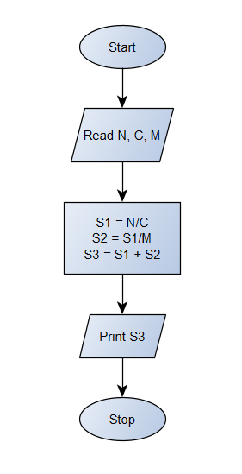

Python Program

N = float(input(**"Enter the amount Bob has : Rs."**))  
C = float(input(**"Enter the cost of one chocolate : Rs."**))  
M = int(input(**"For how many wrappers does Bob get one free chocolate : "**))  
S1 = int(N/C) *#S1 = No. of chocolates Bob gets*if M==0:  
 S2 = 0 *#S2 = No. of free chocolates Bob gets*else:  
 S2 = int(S1/M) *#S2 = No. of free chocolates Bob gets*S3 = int(S1 + S2) *#S3 = Total no. of chocolates Bob gets*print(**"Total number of chocolates Bob gets :"**, S3)